Social Media: Friend or Foe?

Team 10

Florida State University

**Abstract**

This study focused on the effects of social media use on the mental health and quality of face-to-face interactions. Specifically, we examined how Florida State University undergraduate students’ use of social media affects their mental health and ability to communicate in person. We determined why FSU undergraduate students used social media to communicate, how often they spend time on social media, and whether or not they believed that their use of social media has a negative impact on their mental health. We obtained our 108 survey participants by asking FSU undergraduate course professors to distribute our online Qualtrics survey link to their classes, by posting our survey link in FSU Undergraduate related Facebook groups, and by emailing students in our own classes. Overall, after analyzing the responses from students, it appears that the sample of FSU undergraduate students are evenly split when it comes to cognitive and emotional impact as a result of social media usage. It can be concluded that the same sample of students who responded to the survey using words like “unaffected” were also the same students who reported that they were “never stressed out by social media” and did not feel like their communication skills had been hindered because of social media use. With the exception of some outliers, the remaining half of the sample existed at the other end of the spectrum: heavily affected in both the cognitive and emotional areas. This half of the majority was largely affected when social media did not deliver responses that they had hoped for and felt unappreciated; they also felt as though their communication skills had been impacted as a result of social media. This survey begs the question as to whether the majority that was unaffected uses social media less or are they just more confident with their communication skills, and as a result continue to use social media daily despit it’s adverse affects on their life.  ***Keywords*: social media, mental health, impact**

**Problem Statement**

A study conducted by Marketing Department at Baylor University found that, “college students commonly view their cell-phone as an integral part of who they are, and/or as an important extension of themselves” (Roberts, 2014). Similar to this study, we the researchers, have noticed that college students are relying on the use of cell phones and social media to define themselves instead of in person. We will research the decreasing quality of face-to-face interactions as a result of technology use, specifically social media, and its impacts on the mental health of students. For this study, we are seeking to research how this problem impacts Florida State University Undergraduate Students both socially and mentally. The company/organization that we would like to work for is the Florida State University Health Services. Currently, teenagers and young adults are losing their interpersonal skills due to the lack of physical human interaction and excessive use of digital technology. Additionally, this reliance on social media has shown many negative effects on mental health (Amedie, 2015). The current gap between what is real and what is desired is quite drastic. Realistically, many students are currently relying solely on social media to fulfill their communication, gratification and self-esteem needs. This has led to a decrease in self-confidence and an increase in both anxiety and depression among the students (Amedie, 2015). Ideally, everyone would be able to have a healthy online and offline lifestyle, be able to form relationships, and communicate effectively in the modern world. Our research purpose is to explore why students may prefer using social media to communicate in comparison to speaking to someone face to face. We would also like to understand the mental impact that technology has on their interpersonal and intrapersonal relationships.

**Significance and of Study**

This research problem holds significance not only for the sake of the students at Florida State University and University Health Services organization, but also a social networking site such as Facebook. Students acquiring the ability to communicate and build relationships effectively will benefit them as they look for work in the future and continue to create a healthy lifestyle for themselves. This research benefits the Florida State University Health Services by giving them information regarding the effects of technology and social media on the mental and emotional wellbeing of young adults. This will allow them to properly recognize/address these issues and find solutions to benefit students suffering from them. Social networking sites, such as Facebook, will also be affected by this study by using the data to adapt their products. This will provide them with the data to make their products more popular and usable by showing what aspects are being used. By analyzing the data that results from this research, these companies can tailor their applications to be effective yet not yield any dangers to the mental health of its users. These companies can also use data to better their current applications and make changes that promote a healthy balance of technology use and face-to-face interaction. Even if these companies can alter their apps to maintain functionality but require less reliability, it would be a good starting point to help to bridge the “link between heavy cell phone use in young adults and depressive symptoms ” (Fisher-Titus, 2018). Ideally, these companies can learn how to remain successful yet post minimal harm on its users. It will also allow them to recognize what potential health risks may be involved with their product so that they may properly address them and work to prevent these issues from further developing.

**Research Questions**

**RQ1:** Do FSU undergraduates believe that social media has negatively impacted their ability to communicate in a physical environment? How? Why?

**RQ2:** Do students think the use of social media has personally impacted them in non-social aspects of life (Physical/Mental Health, etc.)? How?

**RQ3:** With the knowledge of the negative impact that heavy social media use has , will FSU undergraduates change their communication habits and or social media use?

**Literature Review**

In the two short decades since it’s soft creation, social media has taken the world by storm. It’s impact has been so large, social media has altered the course of modern society, with society’s youngest generations adopting it and making it their own. Young adults are now so engaged with social media, that has become a normal part of their day-to-day lives and many consider it a part of their own identity. They spend hours on social media platforms communicating with friends and people across the country, sharing news, information, music, media, and art. These massive digital spaces provide an environment for them to develop their social and interpersonal skills. This is seen by the promotive feeling of belonging and self-disclosure, two properties that “support identity development during adolescence” (Davis, 2012). And while there are factors of social media that seem beneficial, that is not completely the case. Given the fact that college students primarily use cellphones to go on social media, and that there has been an increase problem linking negative mental health effects and going without a phone, it is beneficial for researchers to find causes and effects of internet use and psychological well-being along with the impact that social media and the internet has on mental health. That is why we are researching this phenomenon amongst our undergraduate student population.

**Content of research problem:**

Nomophobia, the fear of going without a mobile phone, has increased into a new and emerging problem noticed among young adults. There has been a noticeable correlation between anxiety and irrational fears when people face being detached from the digital world. (Bragazzi, 2019). A study was conducted with college students to explore cell phone dependency. The researchers came to the conclusion that a strong correlation between the subjects with strong cell phone addiction and how they “adopt maladaptive coping styles when confronted with stress” (Bragazzi, 2019). Seeing that there is a strong correlation between cell phone dependency and a more harmful behavior, may be the same when it comes to social media and poorly adjusted behaviors.

Another study at a university in Texas studied the different functions of a cell phone and categorized the different applications to see whether or not one category had any association to cell phone addictions (Roberts et al, 2014). The researchers had surveyed college students as well, by giving them a list of twenty-four applications, varying in their functions, whether it be the basic phone function, social media, or entertainment, and asked how often the participant would use it. The researchers discovered that out of all the different functions of a cell phone, the number one category that a phone was used for is social media. (Roberts et al 2014). Overall this study shows a strong correlation for college students being addicted to social media, which helps in conducting our research because we are trying to find a correlation between negative mental health effects and social media.

**Cause and Effect of Internet Use and Psychological Well-Being:**

Social media is a feature that consumes many college students time when on an electronic device. Social media usage has both positive and negative implications. It can be positive because it can help students keep in contact with loved ones, help build relationships and help students look for jobs. However the overuse of social media can have negative effects on students' mental health and “can be linked to a decrease in quantity and quality of face-to-face interaction among college students” (Drago, 2015). Not only do students avoid interacting face-to-face, the interactions are also more awkward and do not last for a long span of time. As well as decreased human interaction, social media can also be linked to an increase in hostility, depression, and social anxiety (Chih-Hung et al., 2014). The purpose of our research is to study the true effects of social media on college students. The literary finding below discuss the effect social media can have on college students.

College students communicate in a multitude of ways, the most common being using social media or their cell phones. Drago (2015) found that students favored using their devices to communicate rather than speaking face-to-face. While doing observations, Drago (2015) found that a majority of participants used technology in a group setting instead of communicating with the people around them face-to-face. Not only is interpersonal relationships affected by technology but interpersonal relations are also affected. An increase in social media use can be linked to higher markers for depression, hostility, and social anxiety (Chih-Hung et al., 2014). This study shows a similar demographic being negatively affected by increasing social media usage. Chih-Hung et al. (2014) studied a group of adolescents slowly having them increase social media usage. The surveys given to participants showed that increasing social media usage caused them to have more mental health problems (Cih-Hung et al., 2014).

There is undoubtedly a particular correlation between the cause and effect relationship of social media usage and psychological wellness, explicitly, the driving components that empower frequent media utilization and the subsequent emotional effect(s). In the article, Loneliness as the Cause and the Effect of Problematic Internet Use: The Relationship between Internet Use and Psychological Well-Being, it explicitly connects with our subtopic on the grounds that it tends to the driving element (cause) for frequent and excessive social media reliance, for instance, negative social aptitudes (Kim, Larose, & Peng, 2009). Furthermore, this theme goes into detail on the impact of social media reliance, for instance, further forlornness.

In an additional dialogue, Social Media Use and Mental Health among Young Adults, our study was reflected in the article’s study of the connection between online networking conduct/utilization and self-destructive behavior. This article is particularly explicit as far as the reason for self-destructive behavior/suicidal tendencies with respect to innovation and web based life. The examination clarified in this article demonstrates an immediate connection between vaguebooking (alarming social media posts to gage attention) and self-destructive inclinations and activities. This article references the subtopic, Cause and Effect, since it demonstrates and talks about how vaguebooking conduct is in actuality predictive of suicidal conduct. In summary, vaguebooking - a social media behavior, is in fact considered to be a cause and that the suicidal behavior represents the outcome and serves as the correlating effect.

**Impact that social media/internet usage has on Mental Health**

Technology plays a central role in the lives of young adults. Although social media has improved mass communication and inspired further technological development, being so plugged into the technology that hosts social media has caused issues for its young adult users. These young adults are experiencing mental health issues and trouble communicating in face-to-face situations, because “they fail to fulfill a need for social connection by opting for digital means of communicating” (Rasmussen et al, 2019). This section will review the literary findings and their details about the impact of social media usage on the mental health of young adults.

Based on his research, Amedie (2015) concluded that social media has negatively impacted its users’ mental health causing them to be “overly self-conscious, anxious and ultimately depressed”. Amedie (2015) also determined that users who spend more time on social media typically show more prevalent and significant effects. Daniel (2015) built upon this idea, claiming that the increasing use of social media has led to decreased attention span, memory capacity, and many other issues in students. Additionally, based on her own research, Daniel (2015) concluded that social media is not just causing mental issues like anxiety but is chemically “reshaping” our brains, impacting our brain’s “reward system” and causing addiction. This research shows that social media creates a cycle where students are experiencing and developing negative mental conditions from social media, but are also becoming more and more addicted to its use.

**Conclusion:**

As much as social media can help students, when overused it can have negative effects. Many researchers find social media usage can have a negative impact on how college students communicate. Using Drago’s (2015) study we support our claim that increasing social media usage has a negative impact on face-to-face communication. Through our surveys we expect similar results, college students prefer to communicate using their devices than face-to-face. Despite this being the preferred method it may not be the best method. Chih-Hung et al. (2014) found that increasing social media usage increased markers for adolescents experiencing depression, hostility, and social anxiety. This was concluded by giving surveys after increasing students social media usage. The extent of social media implications had on adolescents is not known some say it can also lead to loneliness and negative social aptitudes (Kim, Larose, & Peng, 2009). Overall, these studies support the notion that social media dependency has an adverse effect on the face-to-face communication and mental well being of young adults.

**Methods**

**Data Collection Methods**

We used surveys as our research method to aid us in answering our research questions. Using an assortment of open/close-ended questions and distributing them in an online survey format allowed us to gather data from 100 undergraduate students. The survey was easy to distribute virtually and in person, which made it versatile enough to suit our teams needs. We were able to gather demographic and contextual information through our research method without intruding upon our subjects. Our survey was comprised of 20 multiple choice and 2 open response questions.

**Population, Sample, and Sampling Techniques**

The target population for our research project is current Florida State University undergraduate students. The two most appropriate data collection methods are voluntary and convenience sampling. We used convenience sampling, by sending emails with a link of our survey to the members of our current classes and the course instructors. combat gaining responses from the same participants we each selected classes that have a different demographic, there was no overlap in course distribution. We used voluntary sampling, by posting links to our surveys on the class pages on various social media platforms. For instance, all classes have an official Facebook group page so we posted the link on those pages, asking users to take the survey.

**Participant Recruitment Process**

To recruit participants for our research proposal we created an online survey and posted a link to different groups the researchers are in. The recruitment will take place around the Florida State University campus and will be distributed virtually through a Florida State Qualtrics survey link. This will ensure that we have a concrete database of our results. The link was sent out to various groups and Facebook pages to ensure the largest sample size possible, we posted these with a goal of reaching 100 participants. In the end we reached 103 FSU undergraduate students. Being that we distributed the survey to people virtually we are relying on voluntary participation from our participants.

By distributing the link to our survey to CCI students through sending messages to their professors, through sending Canvas emails to people in our own classes, and through posting in Facebook groups, we were able to obtain 103 responses, and 98 of them are complete.

Our survey participants were mostly females – specifically, 56 (62%) of the participants were females, while only 32 (35%) were males. Additionally, as shown in Figure 1, the majority of our participants were upperclassmen: 37 (41%) of the participants were juniors; 36(40%) were seniors.

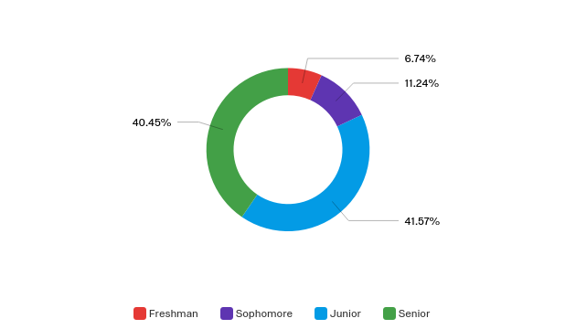

*Figure 1.* School Year of FSU Sample College Students

For social media platforms students used we found the mean of usage per social media platform, as indicated in Figure 2, 58 (69%) indicated that they used Snapchat more than 7 times a day, making it the most-frequently utilized social media platform. Other frequently used platforms include Instagram, which was used by 38 (45%) of users more than 7 times a day, and Twitter, which was also used by 23 participants (27%) more than 7 times a day. Youtube and Facebook were among the other most frequently used platforms. On the other hand, Tumblr, Pinterest, and Reddit were among the least- frequently used social media platforms for our participants. 

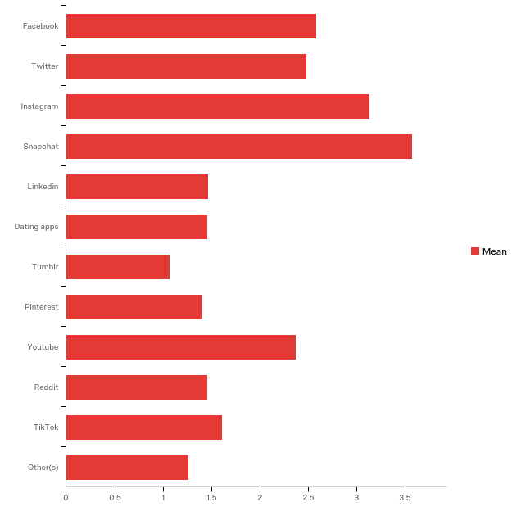

*Figure 2.* Social Media Platform Used by FSU Sample College Students

**RQ1:** Do FSU undergraduates believe that social media has negatively impacted their ability to communicate in a physical environment? How? Why?

**Daily usage of social media for undergraduate students.**

Through our survey questions, we found that 32 participants (38%) use social media 0-3 hours per day. Only 1 respondent (1%) used social media for more than 12 hours a day, while slightly more than 5% used their social media 8-12 hours a day.However, a much larger number of participants, 46 (54%) indicated that they use social media for 4-7 hours every day, Figure 3 shows these responses.

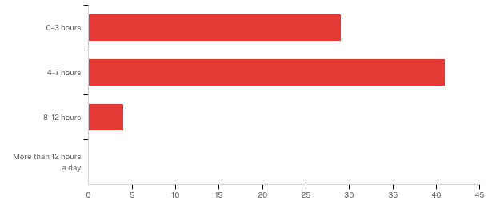

*Figure 3.* How much time FSU undergraduate sample spent on social media per day

**Face-to-face communication.**

Delving deeper into FSU students’ use of social media in the presence of others, we found that 51 participants (60%) used social media 1-3 per week instead of interacting with family and friends. Additionally, 20 participants (23%) used social media 4-7 times per week when they could have been interacting with family and friends in person, and only 4 participants (5%) stated they do not use social media when in the presence of family and friends. Figure 4 provides a visual breakdown of these usage patterns.

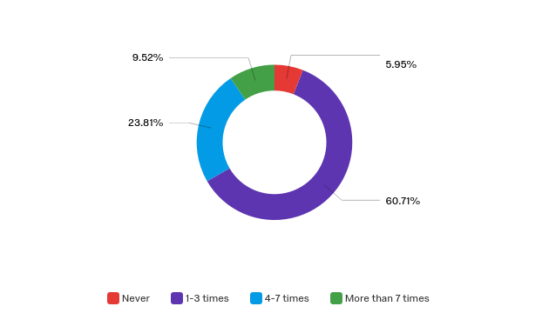

*Figure 4.* use of social media per week when in the presence of friends/family

When asked if they prefer communicating in person or via social media majority, 67 (79%), of the students preferred face-to-face communication. 10 people (11%) responded that they had no preference. Figure 5 shows the visual results of this specific revelation.

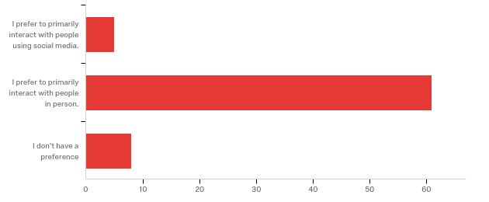

*Figure 5.* Primary interaction medium

**Perceived emotions in response to social media.**

Students had a rather positive outlook when evaluating their attitude towards social media as a communication medium. 41 students (48%) responded that they had a “somewhat positive” attitude for using social media to communicate with others. The other majority, 25 students (29%), were indifferent to a positive response in regards to their attitude about using social media in this way. Figure 5 shows the visualizations for this data.

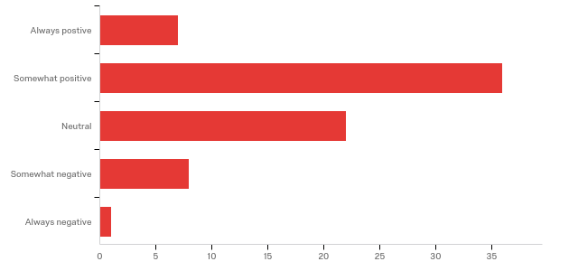

*Figure 5.* Attitude towards social media use to communicate

Overall, our sample indicated that majority of FSU undergraduates use social media more than 4 hours a day. Although there is frequent use they prefer to communicate with people in person and are positive about the way they use it to communicate. In other words, FSU undergraduates use social media for communication when they can not be face-to-face with their peers or family.

**RQ 2:** Do students think the use of social media has personally impacted them in non-social aspects of life (Physical/Mental Health, etc.)? How?

**Do FSU undergraduate students think the time they spend using social media affects their mental health?**

When students were asked how they think their social media use affects their cognitive abilities, half or 50% of the students responded with negative response, alluding to having a shorter attention span and being more easily distracted out of a sample size of 40. 40% of students responded positively, claiming that social media does not negatively affect their cognitive abilities, while the remaining percentage claimed to have neither positive nor negative effects. The word cloud represented by *Figure 6* shows the top 40 words used by students when asked if they think that social media has any effects on their cognitive abilities.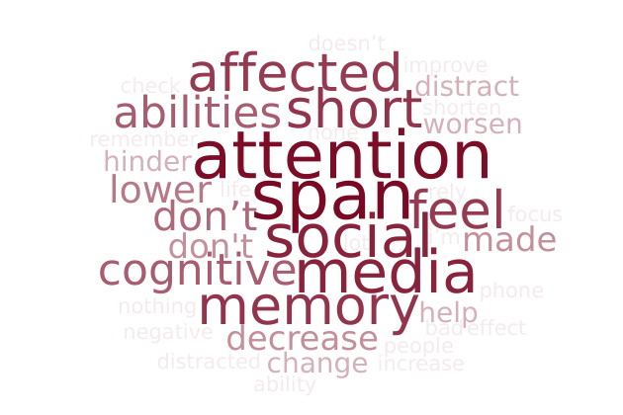

*Figure 6.* Word cloud

*Figure 7.* Students responses to which they believe if social media causes them stress.

When students were asked whether or not social media has caused stressed the majority of students, 54.55%, responded by saying that social media does occasionally leave the student feeling stressed out, (*Figure 6*). 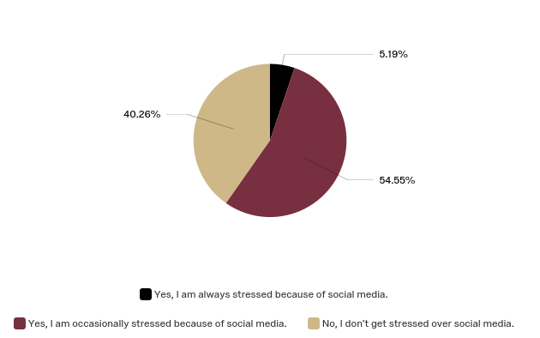

*Figure 7:* Perceived stress level towards social media

**Do FSU undergraduate students think the time they spend using social media affects their self-esteem?**

*Figure 8.* Emotions toward not getting anticipated recognition. Looking deeper into the mental effects that social media has had on FSU undergraduates, 53% of students reported that they felt upset or underappreciated when one of their social media posts didn’t receive the recognition that they expected (Figure 7). Additionally, 43% of students reported that their main purpose for posting on social media was “self confidence”, “satisfaction from peers”, or “influencer aspirations.” These two statistics When students were asked whether or not social media ~40% of students surveyed reported that “Self Confidence” or “Satisfaction from peers” was their purpose for posting on social media.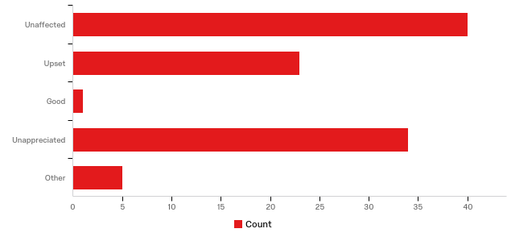

*Figure 8:* Emotions toward not getting anticipated recognition

**Do FSU undergraduate students think the time they spend using social media help or hinder them to sustain a healthy lifestyle?**

Based off of the responses from students, there is a slight majority of them, 53.57%, are in agreeance that the quick availability of social media has hindered the attitude towards in person communication, (Figure 9). In other words, because of social media, the majority of students think that it has affected the in person communication.

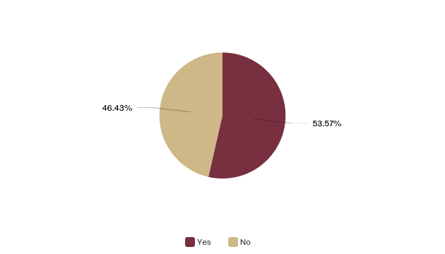

*Figure 9*: Attitude towards social media effect on in-person communication

Overall, after analyzing the responses from students, it appears that the sample of FSU undergraduate students are evenly split when it comes to cognitive and emotional impact as a result of social media. It can be concluded that the same sample of students who responded to the survey using words like “unaffected” were also the same students who reported that they were “never stressed out by social media” and did not feel like their communication skills had been hindered because of social media. With the exception of some outliers, the remaining half of the sample existed at the other end of the spectrum: heavily affected in both the cognitive and emotional department. This half of the majority was largely affected when social media did not deliver responses that they had hoped for and felt unappreciated; they also felt as though their communication skills had been impacted as a result of social media. This survey begs the question as to whether the majority that was unaffected uses social media less or are they just more confident with their communication skills, and as a result don’t need as much gratification from social media posts?

**RQ 3:** With the knowledge of the negative impact that heavy social media use has, will FSU undergraduates change their communication habits and or social media use?

**Does the FSU student feel a change in social media usage would be beneficial?**

Students were asked whether or not they feel like they would benefit from a decreased use of social media, the results showed that 56 (66%) felt that they would in fact benefit from a decrease. While only 22 (26%) students felt that they did not feel a need to change their social media usage. Figure 10 shows the data from this survey response.

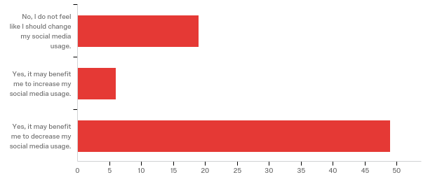

*Figure 10:* Change in social media tendencies

Overall, it appears knowing that social media usage has negative implications does cause students to recognize the need to change their habits, based on the entire study it does not appear students have made any changes. Many still feel they can benefit from actively using social media less in their day-to-day activities.

**Limitations/Future Research**

The two major limitations of our study were in getting our sample population to take our survey, and in gathering accurate responses from those who did. Although we received over 100 responses to the survey, the quality of these responses have placed limitations on this study.Of these 100 responses, at least one-fifth of them did not respond to every question on the survey. We had people not complete the entire survey and we can be sure that all of the responses are reflective of the thoughts that the student had on this topic.

In the future, we could seek out a larger population to distribute our survey to. This could be accomplished by reaching out to faculty in different departments across Florida State University. If we were to continue this research we may also consider refining our research questions to gather more in depth qualitative data about mental health as it relates to social media use. These refined research questions would come from further analysis of established literature in this area of study.

**Conclusion**

In conclusion, based on the survey responses from our 103 participants, we found out a great deal of information about FSU undergraduate students’ use of social media and the effects that has on their mental health and face-to-face communication. First, we determined that approximately 54% of those surveyed use social media between 4-7 hours daily. Additionally, we found that 60% of students surveyed found themselves using social media instead of interacting face-to-face between 1-3 times per week. Despite finding themselves not communicating face-to-face when the opportunity was presented 79% of students preferred to interact with others face-to-face. Knowing how students interact allowed us to begin to assess students perceived emotions towards the ways they communicate.

Despite preferring to communicate face-to-face a majority of students still have a positive outlook on communicating using social media. The positive feelings appear to come from social media being an avenue available when the preferred method of face-to-face is not plausible. There is a slight majority of them, 53.57%, state that the quick availability of social media has hindered the attitude towards in person communication.

Overall, even with the positive attitude toward social media, students do believe that social media is having a slightly negative effect on their mental health. Despite the majority feeling negatively towards social media, the results are too close to definitely state negative or positive emotions. 53% of students reported that they felt upset or underappreciated when one of their social media posts didn’t receive the recognition that they expected. But the second highest portion claims to be completely unaffected (40%) by not getting the recognition they felt appropriate. Despite having split emotions toward the effects of social media a clear majority of students feel their lives could benefit from decreasing social media usage. More than 66% or students surveyed realize they could benefit from decreasing social media usage.

**References**

Amedie, J. (2015, September 2). The Impact of Social Media on Society. Retrieved from<https://scholarcommons.scu.edu/engl_176/2/>

Baird, D. E., & Fisher, M. (2006). Neomillennial user experience design strategies: Utilizing social networking media to support "always on" learning styles. *Journal of Educational Technology Systems, 34*(1), 5. doi: 10.2190/6WMW-47L0-M81Q-12G1.

Barber, B. L., & Blomfield Neira, C. J. (2014). Social networking site use: Linked to adolescents' social self-concept, self-esteem, and depressed mood. *Australian Journal of Psychology, 66(1), 56-64.* doi:10.1111/ajpy.12034.

Berryman, C., Ferguson, C. J., & Negy, C. (2017). Social Media Use and Mental Healthamong Young Adults. *Psychiatric Quarterly*, *89*(2), 307–314. doi: 10.1007/s11126-017-9535-6

Bragazzi, N. L., Re, T. S., & Zerbetto, R. (2019). The Relationship Between Nomophobia and Maladaptive Coping Styles in a Sample of Italian Young Adults: Insights and Implications From a Cross-Sectional Study. JMIR mental health, 6(4), e13154. doi:10.2196/13154<https://www.ncbi.nlm.nih.gov/pmc/articles/PMC6505371/>

Chih-Hung Ko, Tai-Ling Liu, Peng-Wei Wang, Cheng-Sheng Chen, Cheng-Fang Yen, Ju-Yu Yen (2014). The exacerbation of depression, hostility, and social anxiety in the course of internet addiction among adolescents: a prospective study. Comprehensive Psychiatry, 55, 6, ISSN 0010-440X, https://doi.org/10.1016/j.comppsych.2014.05.003.

Daniel, N. (2015, April 21). The Downward Spiral for Cognitive and Social Skills. Retrieved from<https://sites.jmu.edu/almjeldspring15/social-media-and-social-skills/>

Davis, K. (2012). Friendship 2.0: Adolescents' experiences of belonging and self-disclosure online, *Journal of Adolescence, 35*(6), 1527-1536

Drago, E. (2015). The effect of technology on face-to-face communication. *Elon Journal of Undergraduate Research in Communications*, *6*(1). Retrieved from<http://www.inquiriesjournal.com/a?id=1137>

Kim, J., Larose, R., & Peng, W. (2009). Loneliness as the Cause and the Effect of Problematic Internet Use: The Relationship between Internet Use and Psychological Well-Being. *CyberPsychology & Behavior*, *12*(4), 451–455. doi: 10.1089/cpb.2008.0327

Rasmussen, E. E., Punyanunt-Carter, N., LaFreniere, J. R., Norman, M. S., & Kimball, T. G. (2020). The serially mediated relationship between emerging adults’ social media use and mental well-being. Computers in Human Behavior, 102, 206-213. doi:10.1016/j.chb.2019.08.019

Roberts, J. A., Yaya, L. H., & Manolis, C. (2014). The invisible addiction: cell-phone activities and addiction among male and female college students. Journal of behavioral addictions, 3(4), 254–265. doi:10.1556/JBA.3.2014.015 <https://www.ncbi.nlm.nih.gov/pmc/articles/PMC4291831/>

**What we learned**

**Kallayah:** My research experience this semester reaffirmed my decision to continue my education in graduate school. I learned a lot about qualitative research and how it can be used as the main research method for a study. I now know my preferred methods to work with when conducting research and will know what to expect for future research projects. A challenge I faced was communicating clearly with my teammates all semester. I handled this by continuing to be as transparent as possible about why I was absent during certain classes and contributing quality to work to the group all semester.

**Hannah:** This research assignment has helped me learn about the research process in general. I have been taught how to do research before but having never conducted I was not sure I truly understood. Going through this whole process has taught me a great deal about conducting research. Being a group of 6 had its own sets of challenges. It helped me to learn my position in large group projects. It has helped me practice not being a leader in group assignments and to figure out how to make sure everyone's ideas are being heard. A challenge for me personally is not doing everyone's work. Occasionally, it is easier for me just to do the work instead of waiting for people to get it done. I had to take a step back and have faith in my group to get their portion done on time.

**Lily:** This research project has taught me a lot about working with a team. Prior to taking this course, I have never been given a project and then three months to complete it following a strict schedule with all the little deadlines. Another thing I learned from this project, is working within a group of six members. Sometimes it was hard to get us all on the same page at times and communicating all of our ideas between everyone. Eventually we all would get on the right track, but sometimes it took some time.

**Camden:** This research project has taught me many different things within the wide research field. I surprisingly enjoyed working with graphs and analyzing the answers and surveys collected. I also thoroughly enjoyed my team as they were all extremely dedicated and passionate about our subject matter, something that heavily contributed to the success of our group. Early on, our group faced the challenge of distributing our survey to a wide variety of students. We accomplished our goal by continually giving out the survey to different group chats and friend groups.

**Mason:** This research project has taught me a lot about the different aspects within the research process including gathering, analyzing, and presenting data. Additionally, the experience gained working with a team throughout this assignment has taught me a lot about a few efficient and inefficient approaches to this type of research that will be invaluable in the future. As a group, the main challenge we faced was effectively communicating our individual ideas with each other and implementing those ideas to the best of our ability. Overall, we did a very good job communicating as a group and we worked extremely well together, but there is always room for improvement. Relying on group members in this research project has been both a convenience and a discomfort. I am used to doing most of the work in group assignments because my group members usually don’t care about the quality of their work. With this team, I decided to sit back and let everyone do their own thing. I did do some editing throughout the semester for typos, grammatical errors, etc., but I think developing the ability to rely on your teammates has been an amazing experience.

**Avery:** This research assignment has taught me a lot about survey methods - including the benefits and limitations. It has also taught me about professionalism in regards to collecting information and carrying out research. I have also gained a lot of knowledge and practice from working with this group of my peers. Additionally, this research project taught me that there’s an endless amount of content to learn and apply to research. Additionally, I learned from my peers and taught myself a lot about the potential threats and harms in regards to technology and social media as well as the benefits and everything else in between. I think our team did a great job and worked well together while maintaining mutual respect and hosting an open and encouraging atmosphere to exchange ideas and thoughts. I truly enjoyed hearing the thoughts of my fellow group members and gaining knowledge through our insightful conversations and debates.